North South University

CSE215L

Project Report

Project Title:

Submission Date:

Submitted To: Dr. Shafin Rahman (SfR1)

|  |  |  |  |
| --- | --- | --- | --- |
| Name | ID | Section | Group Code |
|  |  |  |  |
|  |  |  |  |
|  |  |  |  |

# Introduction

## Background to the Problem

Credit cards have become a day to day thing in our life. In first world countries almost nobody buys a house or a new car in cash, so sooner or later you’re going to have to use credit to obtain the things you want in life. It’s spread in our country as well. We can buy things on EMI, get ready cash on instance through this.

Services received from our country’s companies are not sufficient enough. If a user loses a credit card he has to face a lot of complicated steps for verification. Besides, getting a credit card is not user friendly as well. It’s a long term hefty process. This is the root problem we are trying to solve.

## Solution to the Problem

We are like a bridge between the banks, user and government. With most of the affiliated banks and government we have access to their data.

From our app user can issue a credit card, get credit card when it’s lost for the stored cards in our inventory. User can verify themselves once in our app with national ID card. Even teenagers can get an account with their birth id card.

Our goal is to make the entire system as easy and user friendly as possible.

## Existing / Related Solutions

Many banks have incorporated our features in their system.

But as we know a person has cards from different banks. With just one click our users can access any of their cards. And get all the services within.

# System Features

1. System Login   
   1. Login is randomized for everyone. If user enters his id and password he will be referred to user page, if admin enters credentials he’ll be referred to admin page same goes for CEO. Everyone can login using the same portal.  
   2. During login user password is hidden. There is also an option for visibility.  
     
   Priority Level: High  
   Precondition: Have to have an account with valid user id and password. System Signup is prerequisite for Login.
2. System Signup   
   1. User can sign up here. Admin and super admin can’t signup. Admin account can only be created by the super admin.  
   2. Insert all credentials like user name, user id, father’s name, mother’s name, government id card details, phone number etc.  
   3. If an existing id of the same id name remains system signup can’t be done. This will be checked runtime on the sign up page.  
     
   Priority Level: High  
   Precondition: Must give all credentials. Have to have valid government ID card. All data have to be valid and all.
3. Add Document   
   1. User can add card and data here. They can store them. Only verified cards by banks affiliated to user accounts can be added.  
   Priority Level: High  
   Precondition: Have to h
4. Issue Card   
   1. User can apply for card here. He has to wait for the admin before the request is processed.

Priority Level: High  
Precondition: Must have a user account

Reset Password   
1. Everyone can change his user id’s password. For this first of all they need to be signed up to their account.

2. Need to enter previous password. Then the system will check while the old passwords match.

3. If old password match then the password change request is processed.  
Priority Level: High  
Precondition: Must have to enter previous password

1. Update Issued Card

1. Admin can issue a card

2. All data should be crosschecked with bank

3. When card issued user card details will be updated automatically

Priority Level: High

Precondition: User must apply for a card first

# UML Diagram

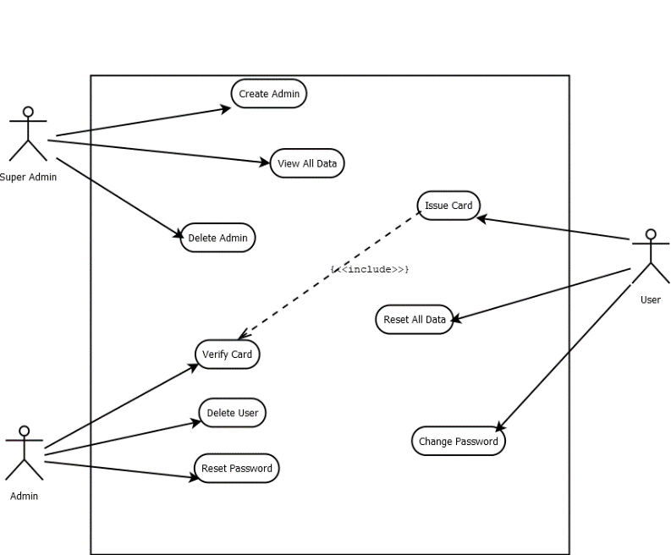

Fig 4.1.1 : Use Case Diagram

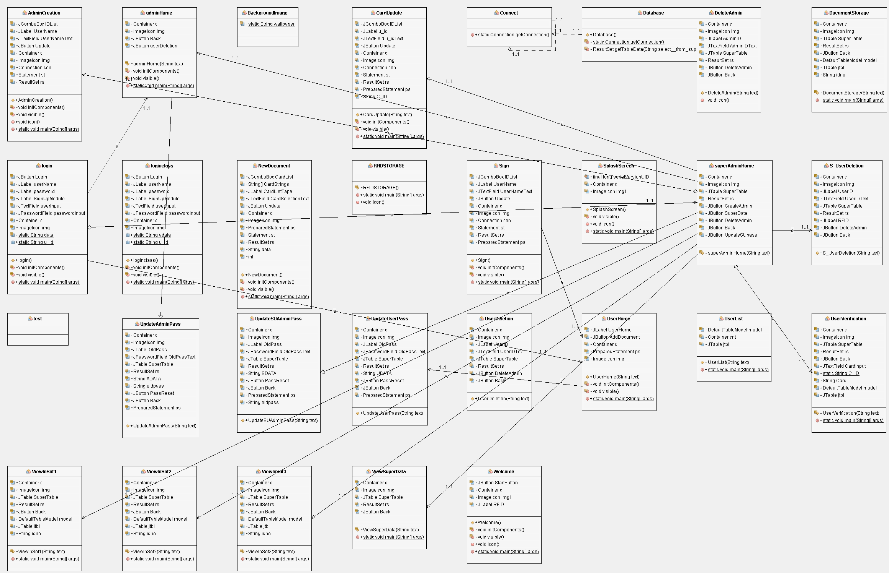

4.2.1 : Class Diagram 1

# Technologies:

1. MySql
2. Xampp
3. Netbeans
4. Notepad++

# System Quality Attributes

Our system is user friendly, fast and reliable. We think everybody can understand our system process easily. They will feel very flexible to use software. Every single person can use our software very easily. And we think it will be very helpful software for the customer. And they will get everything on their hand that’s why they don’t need to go outside home .It is easy to maintain our software, that’s why customer don’t need to take extra pain. Another benefits is that our software have testability, so that if they fall any problem we can test and give a solution easily. Customer can also reuse our software.

# System Interface

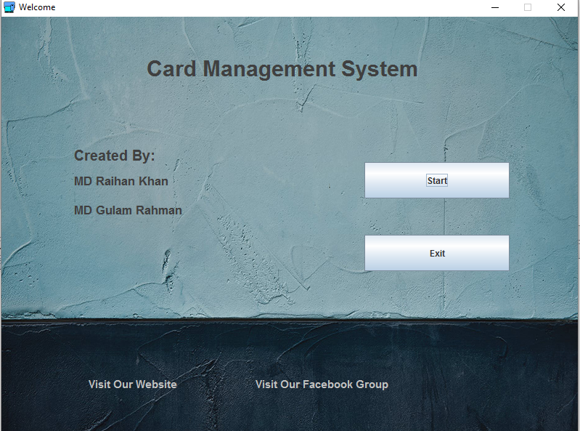

Fig 4.2.1 Welcome

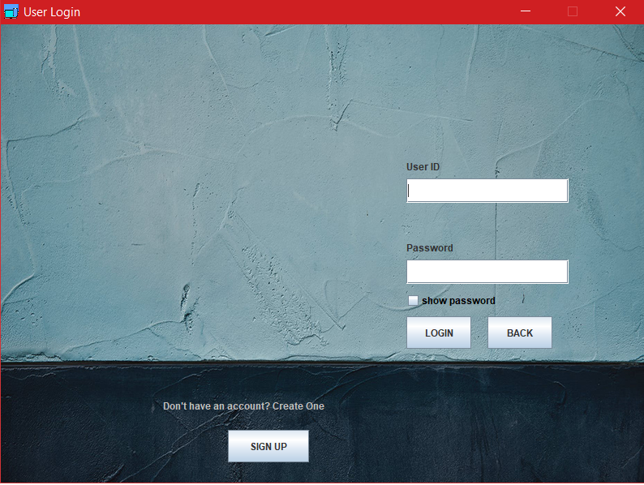

Fig 4.2.2 Login

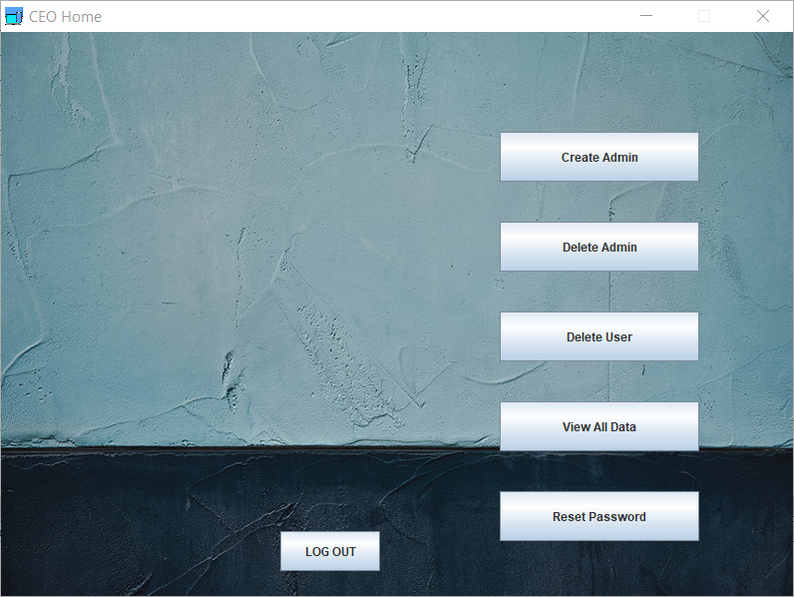

Fig 4.2.3 Super Admin

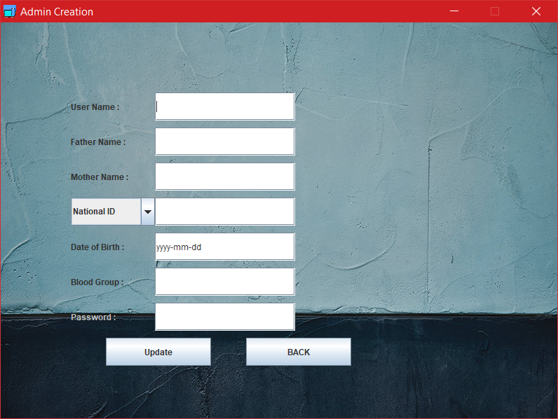

Fig 4.2.4 Admin Creation

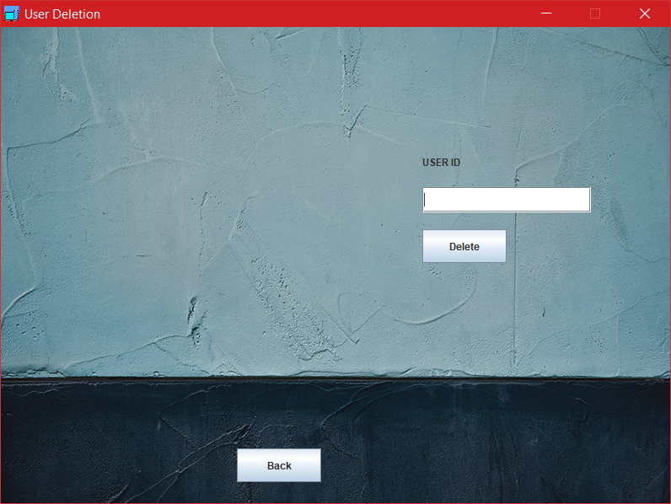

Fig 4.2.5 User Deletion

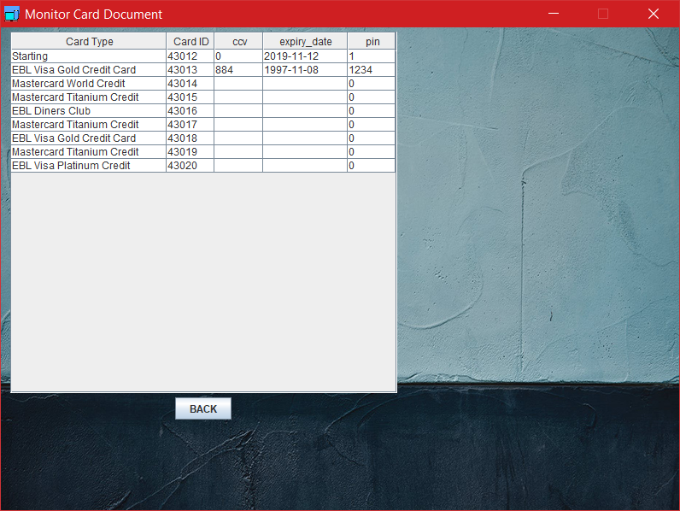

Fig 4.2.6.Monitor Card

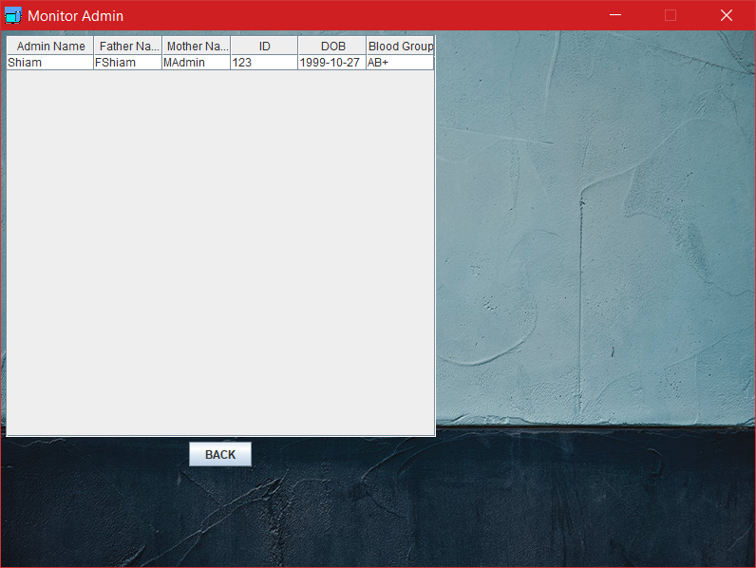

Fig 4.2.7.Monitor Admin

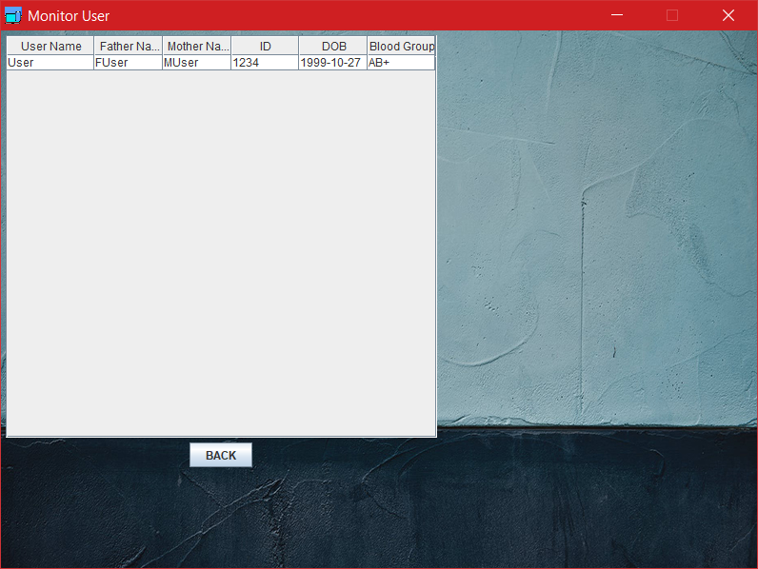

Fig 4.2.8.Monitor User

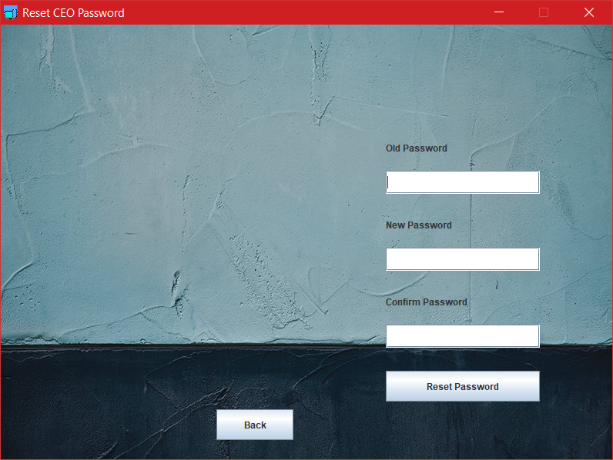

Fig 4.2.8. Reset CEO Password 1

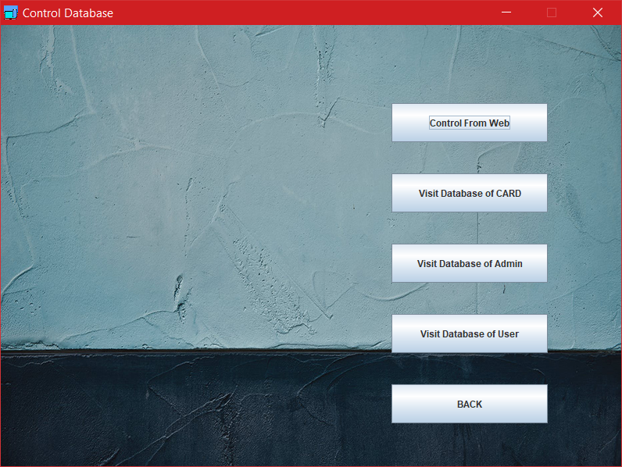

Fig.4.2.9.Control Databse

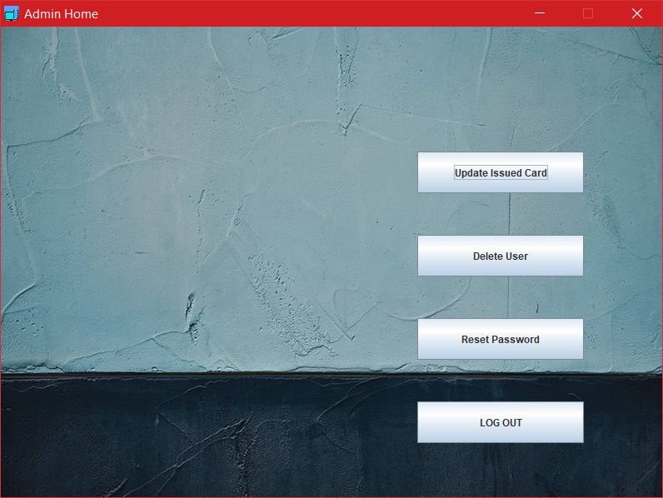

Fig.4.2.10. Admin Home

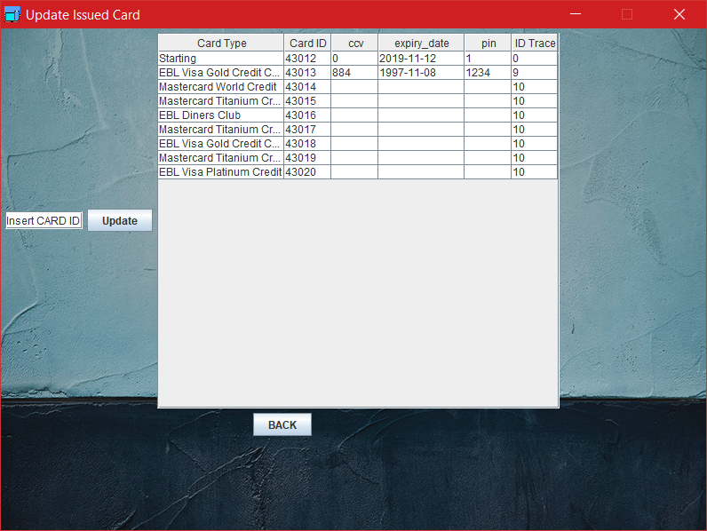

Fig.4.2.11 Issue card



Fig.4.2.12 User Deletion

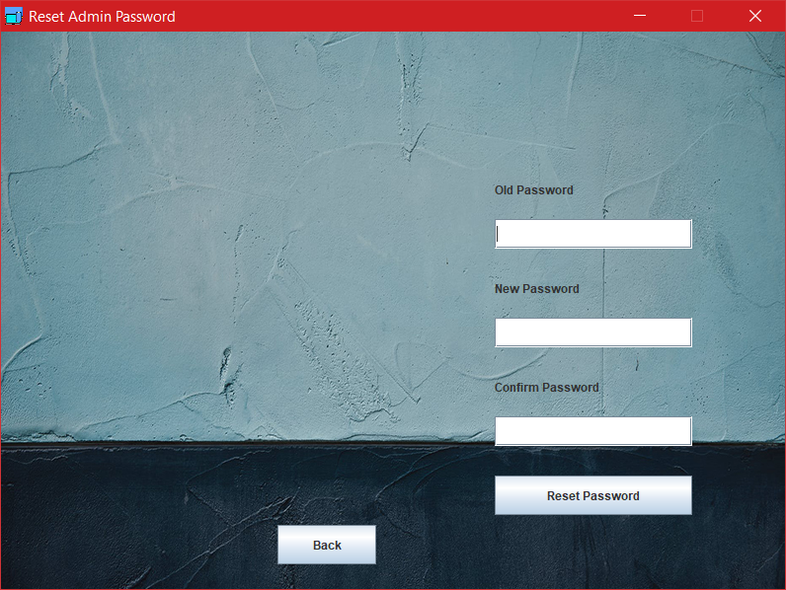

Fig.4.2.13 Reset Admi password



Fig 4.2.15 Update Issue Card 1

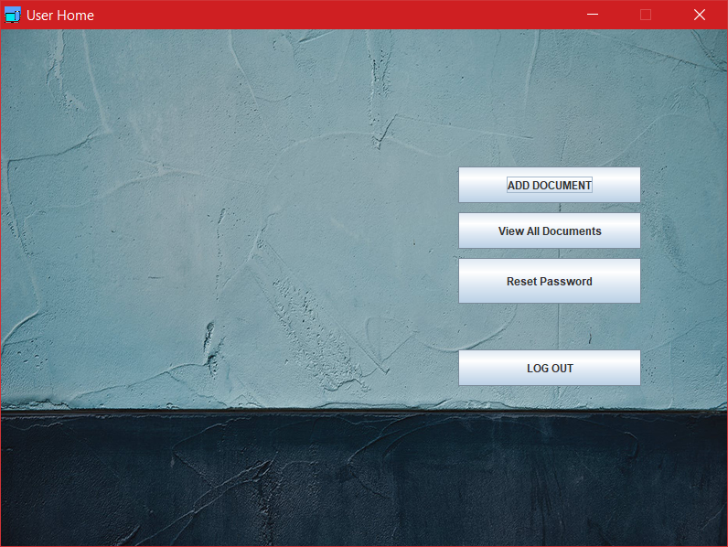

Fig.4.2.16 User Home

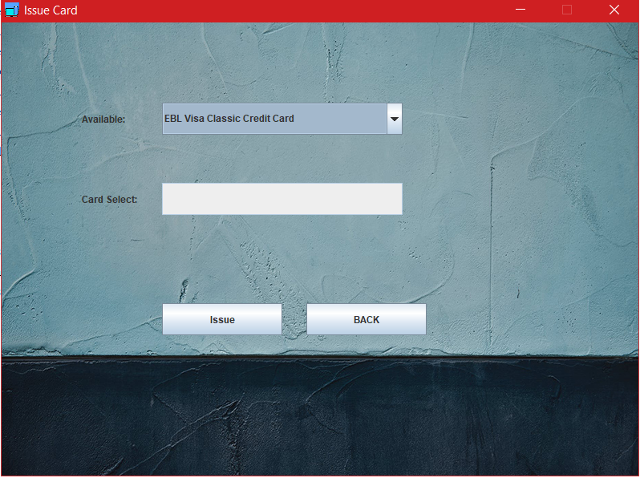

Fig.4.2.17.Issue Card

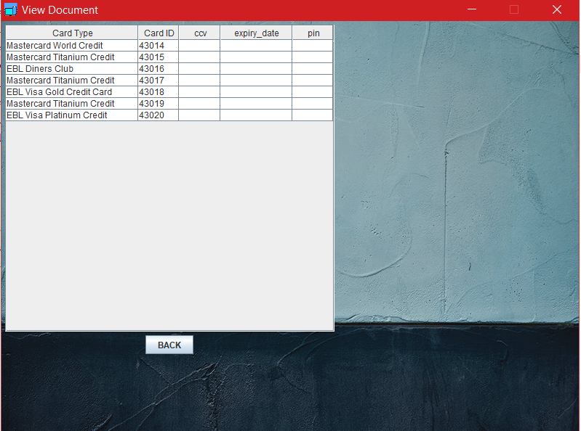

Fig.4.2.18.User Database 1

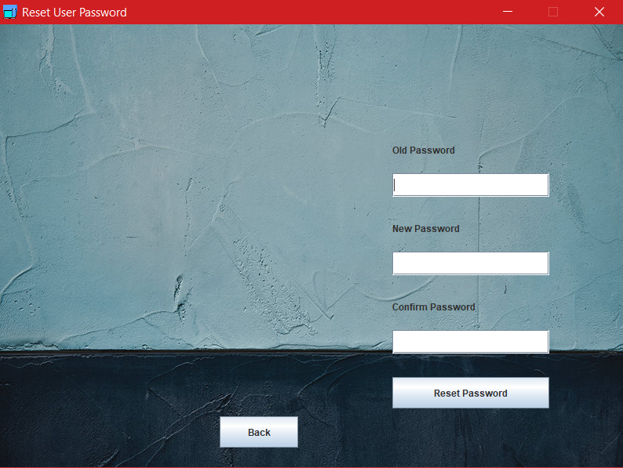

Fig.4.2.19 Reset User Password

# References

* ***R.S. Pressman & Associates, Inc. (2010). Software Engineering: A Practitioner’s Approach.***
* ***Kelly, J. C., Sherif, J. S., & Hops, J. (1992). An analysis of defect densities found during software inspections. Journal of Systems and Software, 17(2), 111-117.***